12/07/15

Hao-En Chang

**ITP-300 Final Project Summary**

About

For my final project, I built a website called “EasyBuy” that has the features of a mini

E-commerce site. Basically, the home page of the website is a login page that prompts the user to enter his or her login information. If the user is new to EasyBuy, he or she can sign up for an account via the link provided in the login page. The signup page checks to validate the new user’s registration. Once the signup is complete, it will direct the user back to the login page where the registered user can sign in.

Site Instructions

After logging in, the user will be directed to the “All Items” page, where all the product listings from all categories can be viewed. On the left-hand side, there are the navigation tabs that are fixed in position. So as the user scrolls the page, they don’t get scrolled up and down. The user can search for any product by their categories as listed in the navigation tabs (Home Supplies, School Supplies, Entertainment, and Others). There’s also the Favorite tab, where the user can view the listings they indicate “Favorite.” In every listing page, there is a search bar up top that allows the user to search by keyword for anything in particular they want to see within the page (or category). The “Add to Favorite” button allows the user to add the items to the Favorite page, which is unique to different users. Below the search bar in every listing page, there is a tiny button for uploading a product listing. The user must fill out all the input fields as well as submitting an image file in order to complete the upload. The newly uploaded item will be available for view back in the listing page immediately after the upload page indicated, “Item uploaded.”

Design

I borrowed a free Bootstrap template for styling the UI of the site. Everything, including buttons and color theme, should look clean and consistent.

Extras

The project fulfilled the following requirements:

* Object-Oriented Programming
* Sessions
* Membership system
* Image file upload
* Paginated results

Database

Favorites table: (with the addition of rating, seller_username, seller_email columns as they are needed in the Favorite page)

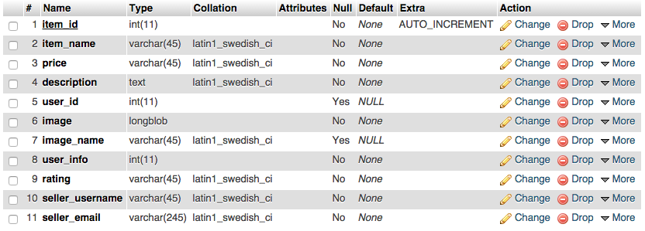

All the listing pages (Home Supplies, All, School Supplies, Entertainment, and Others) have the following table structure:

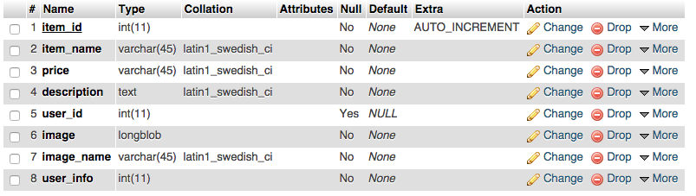

Users table:

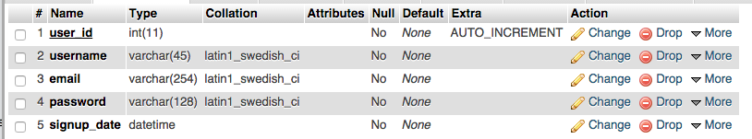

*Note: the user_id of Users table actually matches with the user_info of listing tables. I was not allowed to populate primary key of another table into a table. So I used user_info instead and didn’t define the relationship, but in which case I could populate the user_id of Users table into the listing tables.

To Be Fixed

There are two issues with this site that still need to be considered. First, if the product name upon upload contains apostrophe(s), the user might not be able to delete the product from Favorite as I wasn’t able to correctly escape the single quote in the product name variable. Similarly, it will result an SQL error message if the user types something containing apostrophe(s) in the search bar in all the listing pages.

Second, I have not implemented a way that will prevent the user from going back to the login page after logging in. The user should always log out first before he or she can visit the login page. Otherwise, repetitive logins without logging out can also result in errors.